By: Kenneth Lay -2602119272

Project Documentation

1. Description of the project:

I have always loved making games since I was young whether it is a physical game or a virtual game, even though the process might be tiring and so I made a game for my final project which originally I was going to make a chatting app, this game project I got inspiration from a lot of turn based J-RPG I liked to watch but not play even though this is just a section of the game which is the combat with minimal things to do and it could be frustrating to play like when you gacha in a game but this time its all about your stats. Why exactly did I do it? Well because, I want to spread the Ha… Love for the game of course and I want to introduce a more fun way to do it! So let me introduce my Project it is a turned base battle game where you can only attack and heal, and the best parts all your stats and attacks are randomized, but don’t worry I made it easy by giving the player a bigger value range for their stats because, I too felt frustrated since I kept losing when I don’t give the player in stats advantage.

1. Use case diagram:

1. Activity Diagram:

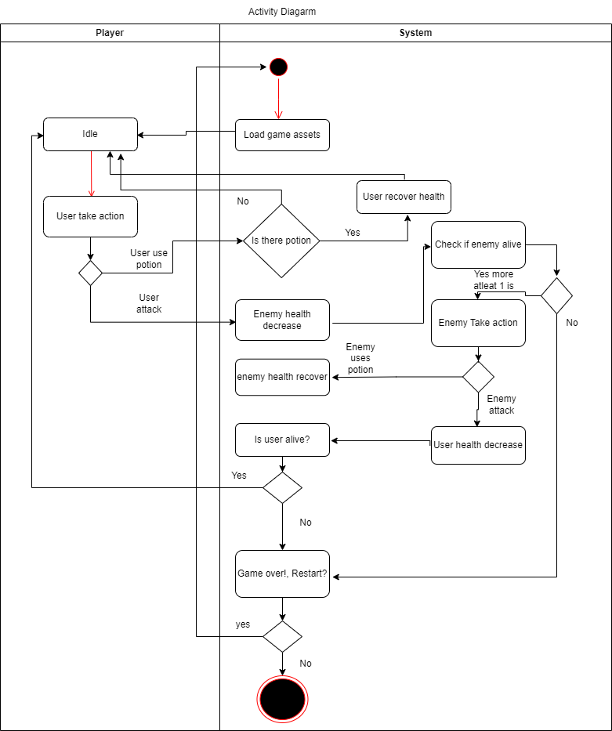

1. Class Diagram:

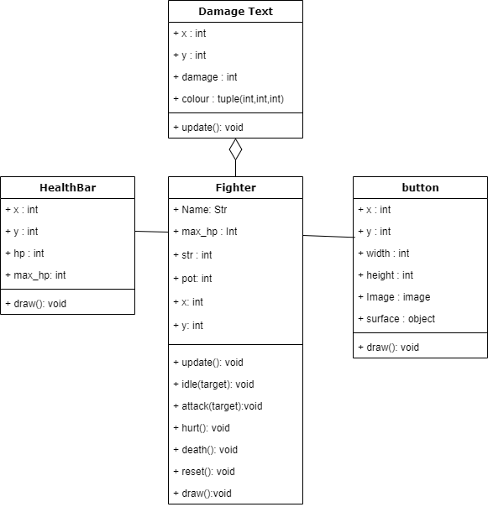

1. Modules:

* Pygame
* Pygame is an essential module for creating games using python, it helps create your game with its build in function and it can help you with creating the game’s UI or display
* Random
* It helps make programming python easier when there is a need to generate random value like random integer.

1. Screenshots:

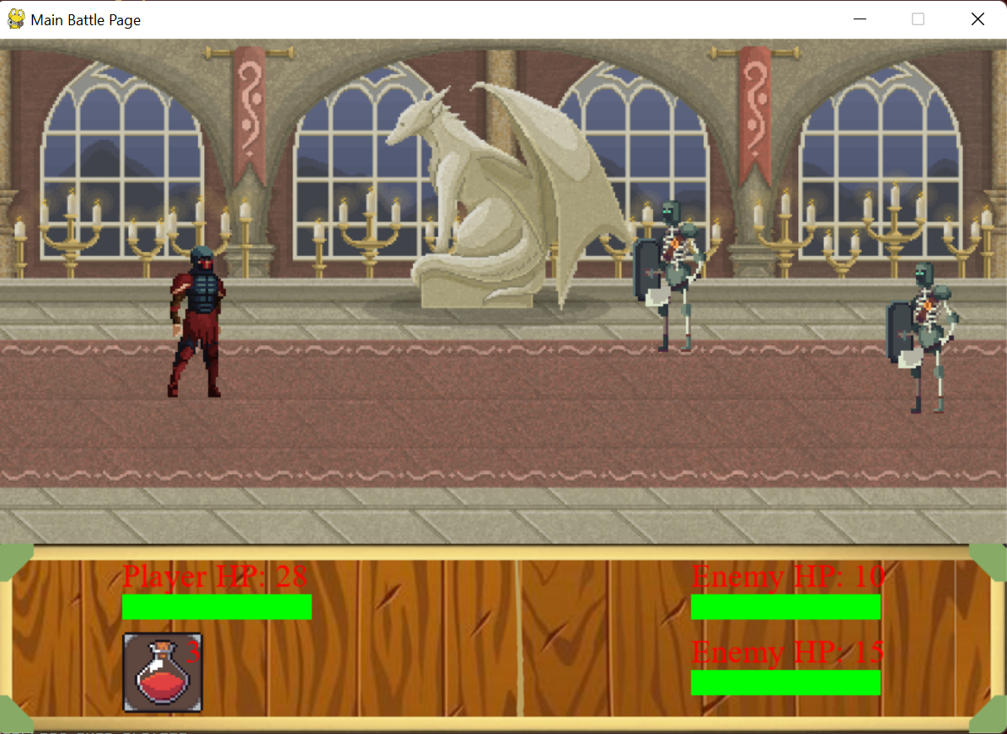

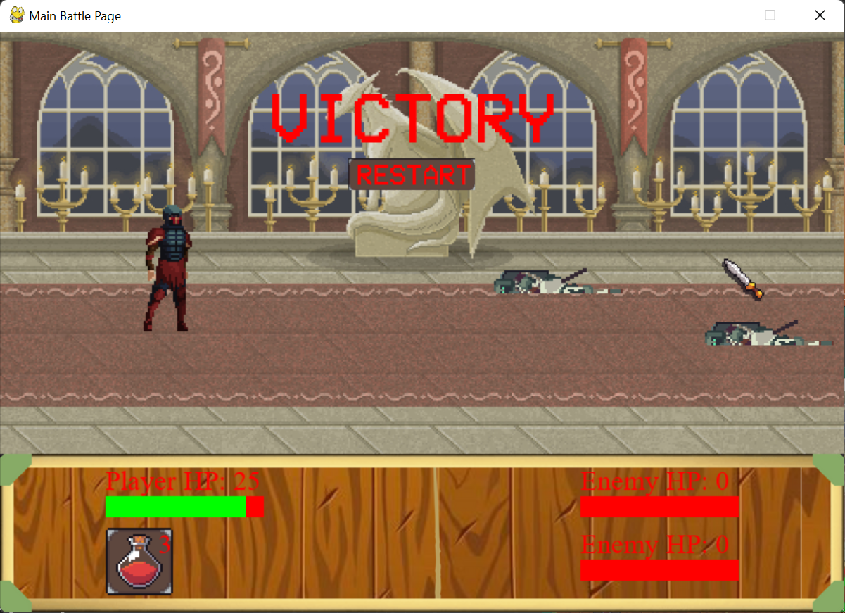

1. Reflection:

I learned a lot of things when making this project actually I would like to say a bit too much in such a short amount of time in making this project and I sometimes still have troubles remembering what I was doing or what variables was there and what was not there. It was stressful since I had to change project concepts 3 times because of uncertainties, data lost, confused and so on, but after I see the final product of my project, I felt relieved it finished on time. But if I were to be honest making games with unity is way easier than pygame… and I wish to no use pygame anymore.

Video Link : <https://drive.google.com/drive/folders/16y-tFvXdI9iw9vpkTRlaP2rpeJlbDAKb?usp=sharing>

Additional Notes:

The character sprites were not made by me neither was the background image or the potion Image.

For the character arts it was made by Szadiart and you can find the download page here for the sprites : <https://szadiart.itch.io/hero-and-opponents-animation>

For the background image bg1 to 3 was founded in craftpix.net and I couldn’t fund the creator name but here is the link to it: <https://craftpix.net/freebies/free-pixel-art-fantasy-2d-battlegrounds/>

And for the last background called derp it was also found in craftpix.net there was also no creator name but here is the link: <https://craftpix.net/freebies/free-elven-land-game-battle-backgrounds/>